Capstone Project: Little Offices

Author(s): Daniel Cender

CST-451 Capstone Project Design Document

Grand Canyon University

Instructor: Professor Bradley Mauger

Revision: 3

Date: May 20, 2023

# **ABSTRACT**

This project, *Little Offices*, is a web-accessible virtual meeting place, equipped with voice and text-based communication features. It closes the gaps between physical working spaces and the growing class of remote-first or hybrid-schedule workers in information technology roles. By eliminating a traditional list-view and “read/unread” feed of a traditional workplace chat application, we can reduce context-switching and the worker’s time is protected from inessential chatter or notifications.

This web application is designed in the style of a top-down traditional 2-dimensional RPG (role-playing game) to give a sense of movement and scale to the space where users meet. Users can authenticate using a basic username/password strategy. Once they’ve selected to join or create a World, they enter the World Scene, where they can utilize voice chat or use the global message thread to send and receive text messages. Embedded into the World is a shared whiteboard intractable item. Users can all open and save edits to it, or even export the whiteboard as an image file.

| History and Signoff Sheet |
| --- |

**Change Record**

| **Date** | **Author** | **Revision Notes** |
| --- | --- | --- |
| April 21, 2023 | Daniel Cender | Initial submission |
| April 23, 2023 | Daniel Cender | Revised Timetable estimates, corrected DDL script |
| April 30, 2023 | Daniel Cender | Logged new Issue record and new Sprint Status Update video |
| May 14, 2023 | Daniel Cender | Logged new Issue Records and App Status Video Walkthrough |
| May 20, 2023 | Daniel Cender | Logged new Issues, Updated scope of deliverables, new functionality video |

| **Overall Instructor Feedback/Comments** |
| --- |

| **Overall Instructor Feedback/Comments** |
| --- |

**Integrated Instructor Feedback into Project Documentation**

☐ Yes ☐ No

**TABLE OF CONTENTS**

**ABSTRACT 2**

**FUNCTIONAL REQUIREMENTS 5**

**DETAILED HIGH-LEVEL SOLUTION DESIGN 6**

Logical Solution Design: 6

Physical Solution Design: 7

**DETAILED TECHNICAL DESIGN 9**

General Technical Approach: 9

Database ER Diagram: 10

Database DDL Scripts: 11

Flow Charts/Process Flows: 12

Sitemap Diagram: 17

User Interface Diagrams: 18

UML Diagrams: 27

Service API Design: 28

NFR’s (Security Design, etc.): 28

Operational Support Design: 29

Other Documentation: 29

**APPENDIX A – TECHNICAL ISSUE AND RISK LOG 30**

**APPENDIX B – REFERENCES 31**

**APPENDIX C – EXTERNAL RESOURCES 32**

# FUNCTIONAL REQUIREMENTS

The *Little Offices* software solution will be implemented using a few pieces of cloud-hosted infrastructure. Implementation will utilize the Google Cloud SQL Database and App Engine product offerings to host the entire service. All code will be hosted and versioned on GitHub in a private repository. Using an iframe embed utility, the shared whiteboard will be embedded from the free online service, WBO (n.d.).

The product will allow users to communicate verbally, visually, and semantically through three different modes of communication. Even if the core “game loop” of 2D navigation isn’t entirely polished for the release of this product, it will be successful if it delivers those three core communication methods.

1. Use the template to list the project deliverables that are to be included external to this Design Specification (Data Dictionary, API Design, etc.).

| Deliverable Acceptance Log | | | | | |
| --- | --- | --- | --- | --- | --- |
| ID | Deliverable Description | Comments | Evaluator (internal or external as applicable) | Status | Date of Decision |
| 1 | External functional requirements list | Requirements in CST-451FunctionalRequirementStories.xlsx | Internal |  |  |
| 2 | Test Case List | Contained in CST-451_Test_Cases.xlsx | Internal |  |  |

# DETAILED HIGH-LEVEL SOLUTION DESIGN

Any POC (proof-of-concept) projects and prototype software technologies created for this project will be listed below:

* As of this latest design revision, no prototypes have been necessary. There are a handful of similar hobbyist applications shared throughout the web to see these tools can be utilized together successfully.
* The primary hosting tools will be through Heroku and Netlify. They have very cheap (often free) tier offerings which will be faster to implement than a fully-fledged cloud service provider like Google Cloud or Amazon Web Services. Those are far more robust, but can require heavy foreknowledge and training in order to provision and connect resources in an efficient and cost effective manner.

| Proof of Concepts | |  |
| --- | --- | --- |
| **Description** | **Rationale** | **Results** |
| 1. |  |  |

| Hardware and Software Technologies |
| --- |
| 1 - Heroku (PaaS Code Container hosting and automatic deployment)  2. Netlify - Website hosting and content delivery |

## Logical Solution Design:

This product will solve an issue of disconnected collaboration over the Internet. Initially, the thought was to provide a physical space for virtual movement for coworkers and students. At the very least, this space should make use of connected microphone devices so all attendees can hear each other and communicate. This grew to affording a text-based chat box in the shared room space, as well as a digital whiteboard utility.

The resulting structure more or less mimics a couple enterprise software solutions in the communications space: Spot and Gather. To provide full functionality, a few application modules are necessary: Security and Identity, Realtime Streaming, Event Messaging, Vector Data Persistence, and a Rendered Geometric World engine. After the first few rounds of planning, I discovered it was best to outsource the Vector Data (Whiteboard editing) portion to an outside service. Browser-to-browser (peer) RTC connections can support the real time binary data streaming required for full voice chat. The Event Messaging module needs to have its own allocation of persistent memory, and so it makes sense to be a server instance. Modern browser engines allow us to implement the Geometric World entirely within the browser, so it can be delivered from a deployed site to the user’s machine directly in a few milliseconds.

## Physical Solution Design:

The following diagram illustrates the general application architecture from a deployment perspective. It includes two client browsers to illustrate where the WebRTC connection will be facilitated.

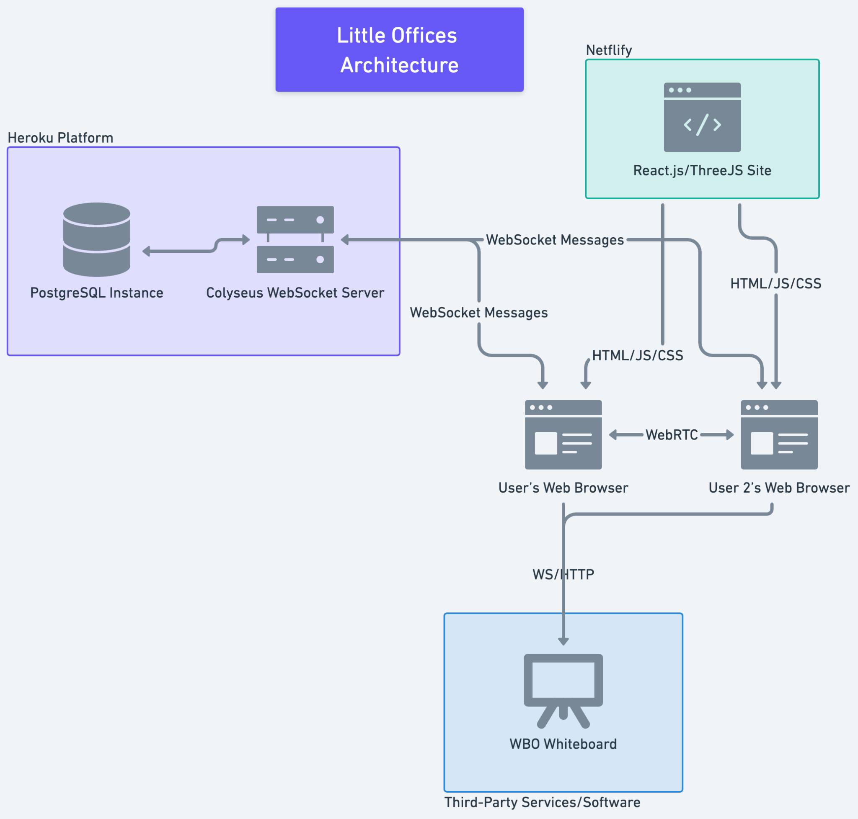

Using a couple well-renowned hosting services, this application will be hosted for free, or at least, very lean cost for its total uptime.

# DETAILED TECHNICAL DESIGN

## General Technical Approach:

I began researching web-based game projects using basic tilesets and sprites (simple pixelated images, often representing player characters in video games). I found examples using both ThreeJS and PhaserJS. While PhaserJS is a fully-fledged game engine built for the browser, ThreeJS is a more barebones framework which can be used to create a variety of geometry-based 2D and 3D structures. I decided to commit to ThreeJS, given that it would stretch my abilities to create complex web programs. It would also force me to solve most of my own implementation problems. I’d found one example program which contained most of the proposed features in this plan, called SkyOffice. However, it uses PhaserJS, so its implementation code will be vastly different from mine, even if some of the structure is mirrored between both applications.

The application will be composed of a basic backend server, driven by a framework called Colyseus, and a frontend web application written in React.js. With the abilities of modern browsers to access system devices and utilize GPU resources, this should be the best blend of performance and stability for this scale of application.

**Key Technical Design Decisions:**

Because of how lofty this project is for the allotted time frame, I elected to use as many open-source tools as possible to help minimize the friction from design to finished development. Below is a list of the tools I’ve selected and the role they fill in the project:

* Colyseus: A WebSocket server which provides a host of utility snippets to easily manage stateful “multiplayer” networked services. With this framework, I can handle instanced state management between multiple connected users by providing my own logical types and message event-handling code.
* React.js: React, and its built-in state management tools through ReactContext, are a common pattern for writing complex-state web applications. I can easily extend default HTML elements and attach complex state response logic to UI updates using this framework.
* React-Three-Fiber: This package allows React applications to easily make use of OpenGL-based ThreeJS rendering tools. This will serve as the bread-and-butter of my visual World map and player Avatar texturing and movement.
* WBO Whiteboard: This free service will allow me to build out the shared whiteboard functionality, but as a lightweight embedding of this fully-featured service. The whiteboard feature isn’t the main focal point of this project, so it’s preferable to outsource this to a third-party service. If the traffic to *Little Offices* grew significantly, I’d deploy my own instance of the WBO whiteboard server (open-source) and use that exclusively.

## Database ER Diagram:

The final design includes four distinct tables.

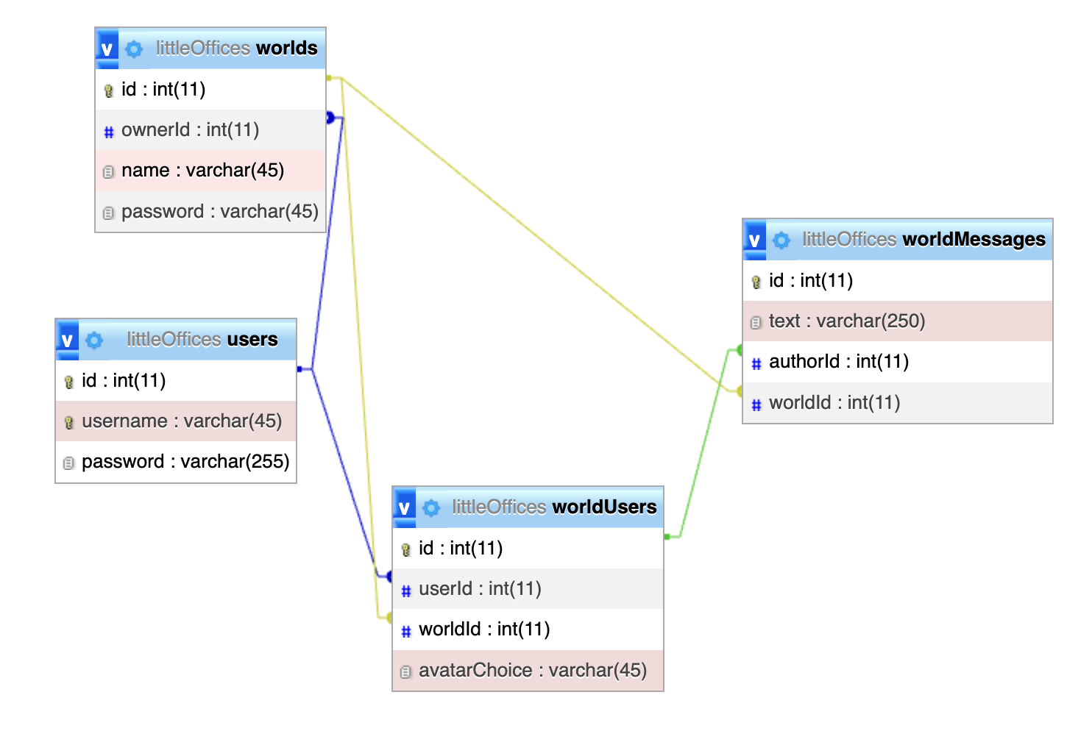

*Note: In the current implementation, the worldUsers table is not utilized, and the connected world users are stored in server memory.*

## Database DDL Scripts:

A total of four tables are used to represent the persistent state of users and Worlds. The schema creation script (MySQL SQL flavor) is below:

—--

CREATE TABLE users (

id SERIAL PRIMARY KEY,

username VARCHAR(45) NOT NULL,

password VARCHAR(255) NOT NULL,

UNIQUE (username),

UNIQUE (id)

);

CREATE TABLE worlds (

id SERIAL PRIMARY KEY,

ownerId SERIAL NOT NULL,

name VARCHAR(45) NOT NULL,

password VARCHAR(45),

UNIQUE (id),

CONSTRAINT ownerId FOREIGN KEY (ownerId) REFERENCES users(id) ON DELETE CASCADE ON UPDATE CASCADE

);

CREATE TABLE worldUsers (

id SERIAL PRIMARY KEY,

userId SERIAL NOT NULL,

worldId SERIAL NOT NULL,

avatarChoice VARCHAR(45) NOT NULL,

UNIQUE (id),

CONSTRAINT userId FOREIGN KEY (userId) REFERENCES users(id) ON DELETE CASCADE ON UPDATE CASCADE,

CONSTRAINT worldId FOREIGN KEY (worldId) REFERENCES worlds(id) ON DELETE CASCADE ON UPDATE CASCADE

);

CREATE TABLE worldMessages (

id SERIAL PRIMARY KEY,

text VARCHAR(250) NOT NULL,

authorId SERIAL NOT NULL,

worldId SERIAL NOT NULL,

createdAt TIMESTAMP NOT NULL,

UNIQUE (id),

CONSTRAINT authorId FOREIGN KEY (authorId) REFERENCES worldUsers(id) ON DELETE CASCADE ON UPDATE CASCADE,

CONSTRAINT messageWorldId FOREIGN KEY (worldId) REFERENCES worlds(id) ON DELETE CASCADE ON UPDATE CASCADE

);

—--

## Flow Charts/Process Flows:

The initial flowchart which drove the design for the site plan and all individual pages:

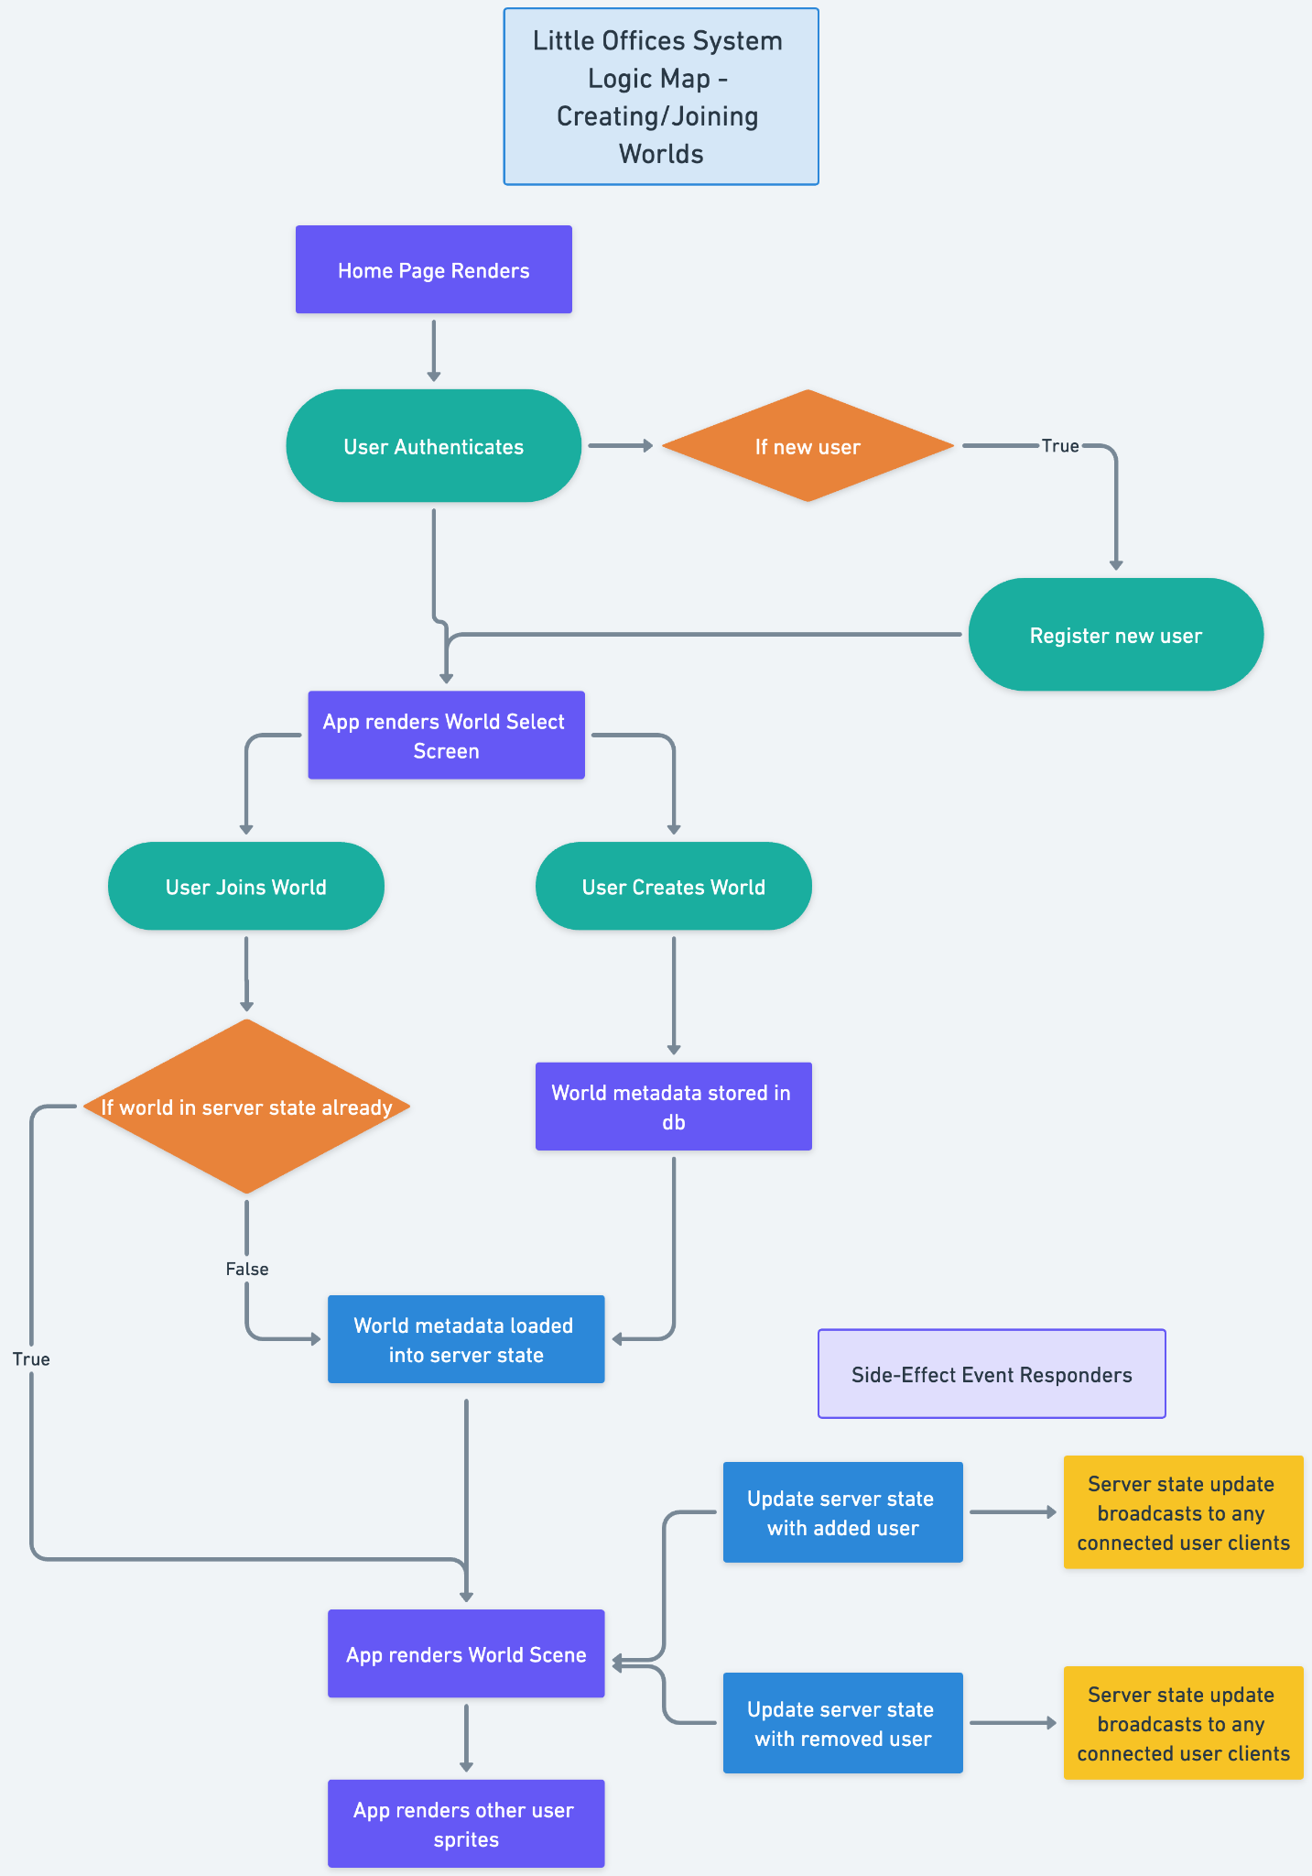

Flow chart for the process of sending/receiving voice chat data over peer connections between browsers:

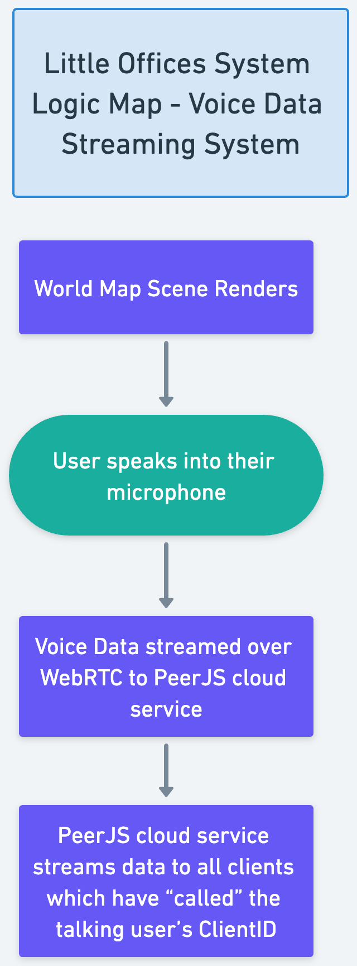

The following is a diagram illustrating the flow for processing text chat messages between clients:

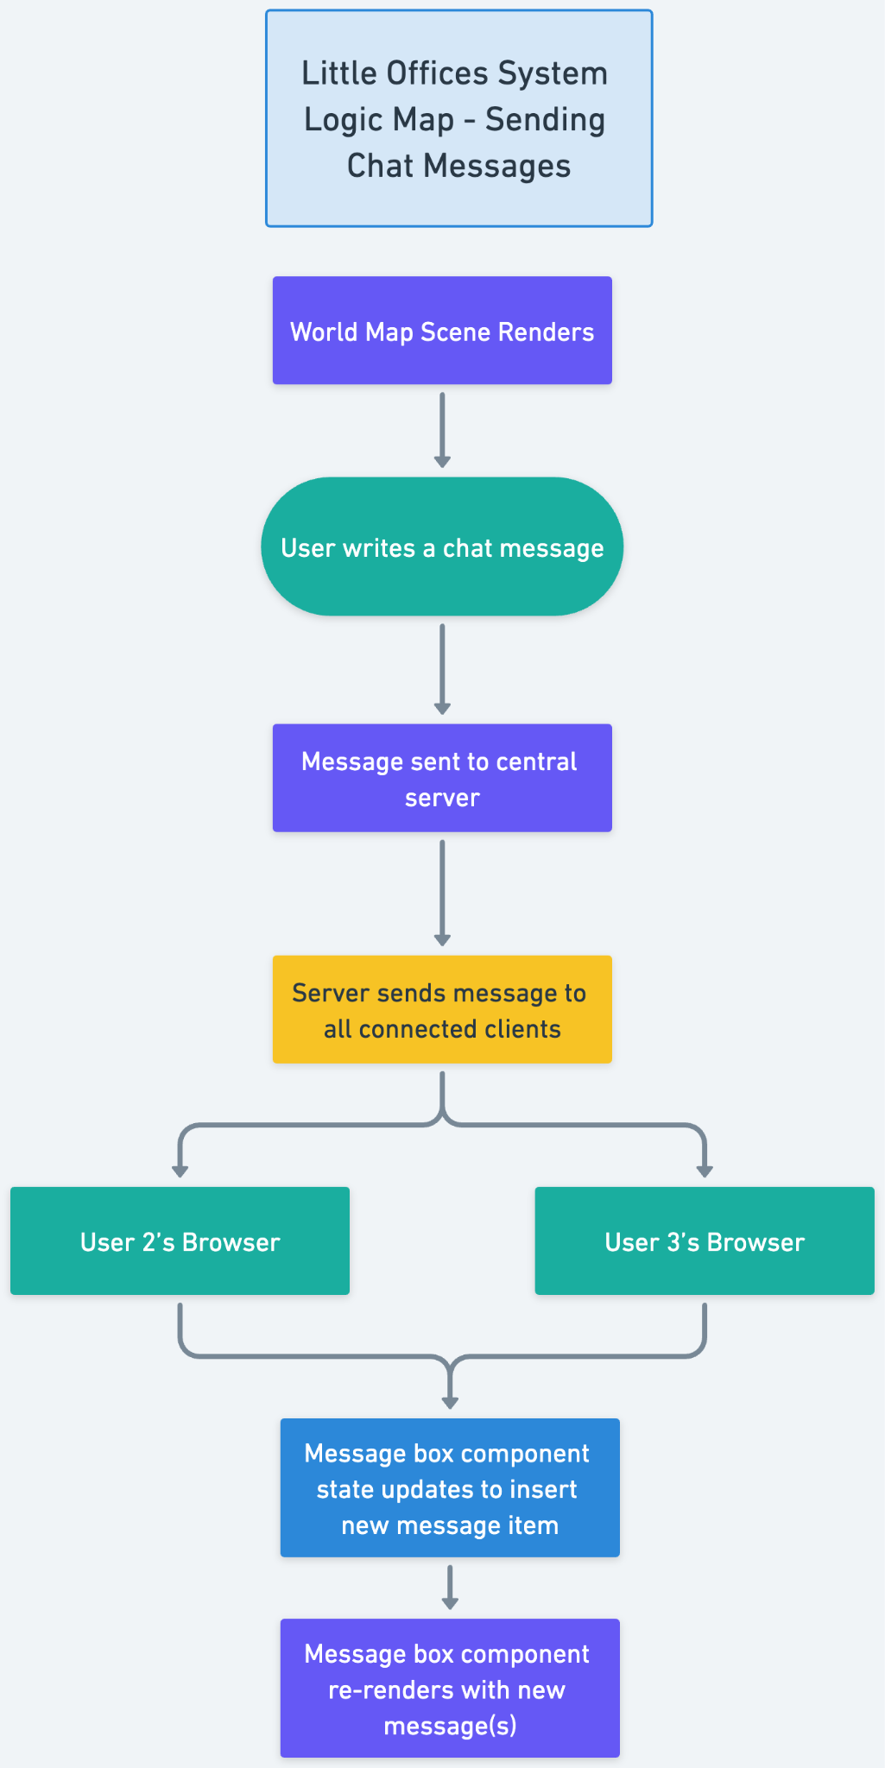

Initially, the following diagram was the original strategy for implementing the shared whiteboard functionality. However, after discovering how easy it would be to plug WBO Whiteboard into the application using some HTML iframe elements and React.js state management, this diagram is now moot:

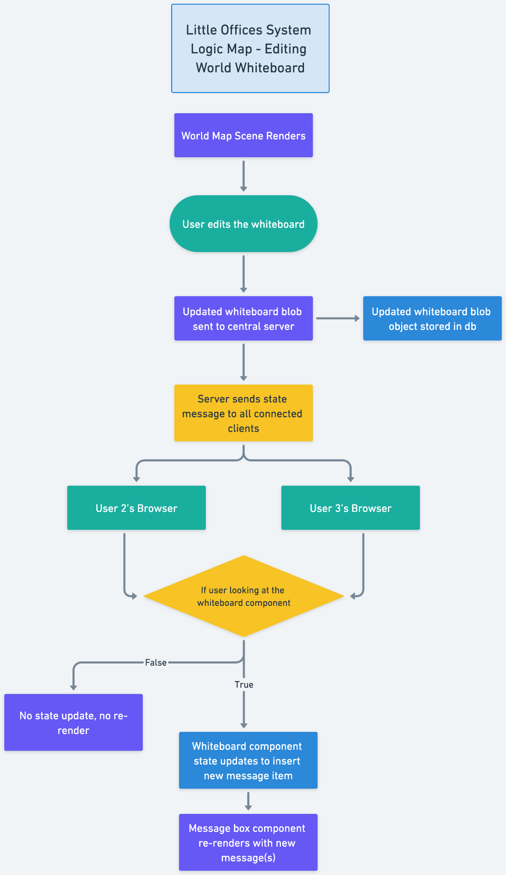

This diagram is a security role matrix for the different user types in each created World. Only the original World creator is considered a World Owner in that space, while all other present clients are World Attendees.

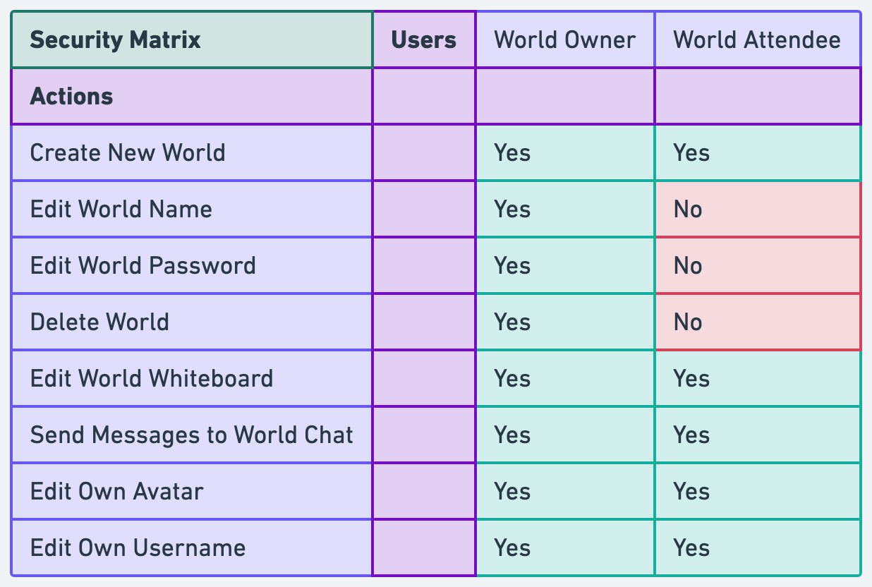

## Sitemap Diagram:

Sitemap diagram contained in Figure below:

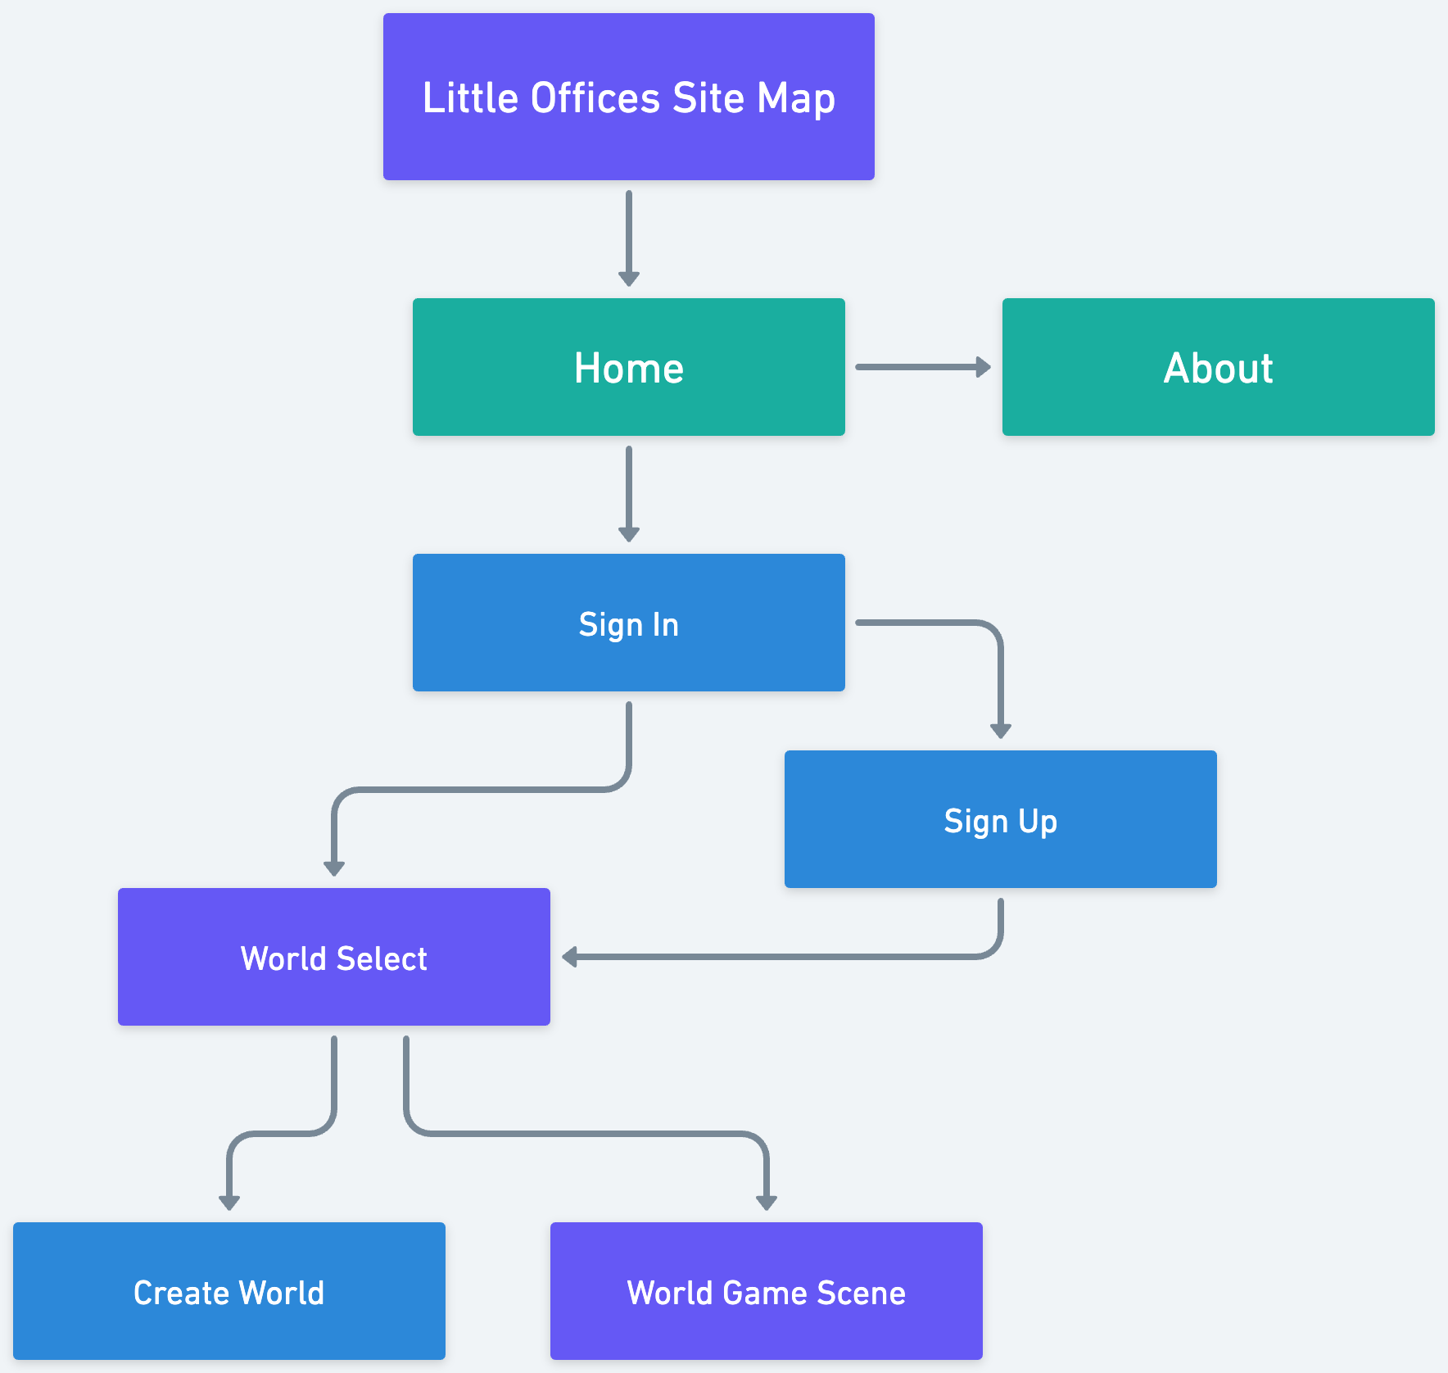

## User Interface Diagrams:

The following are a set of mid-fidelity wireframes illustrating the general structure and palette which will be used to implement the final solution. With a longer budget for time, I’d prefer to fully flesh out high-fidelity designs and wire up a click-through prototype using Figma, Affinity Designer, or Adobe XD.

The home page:

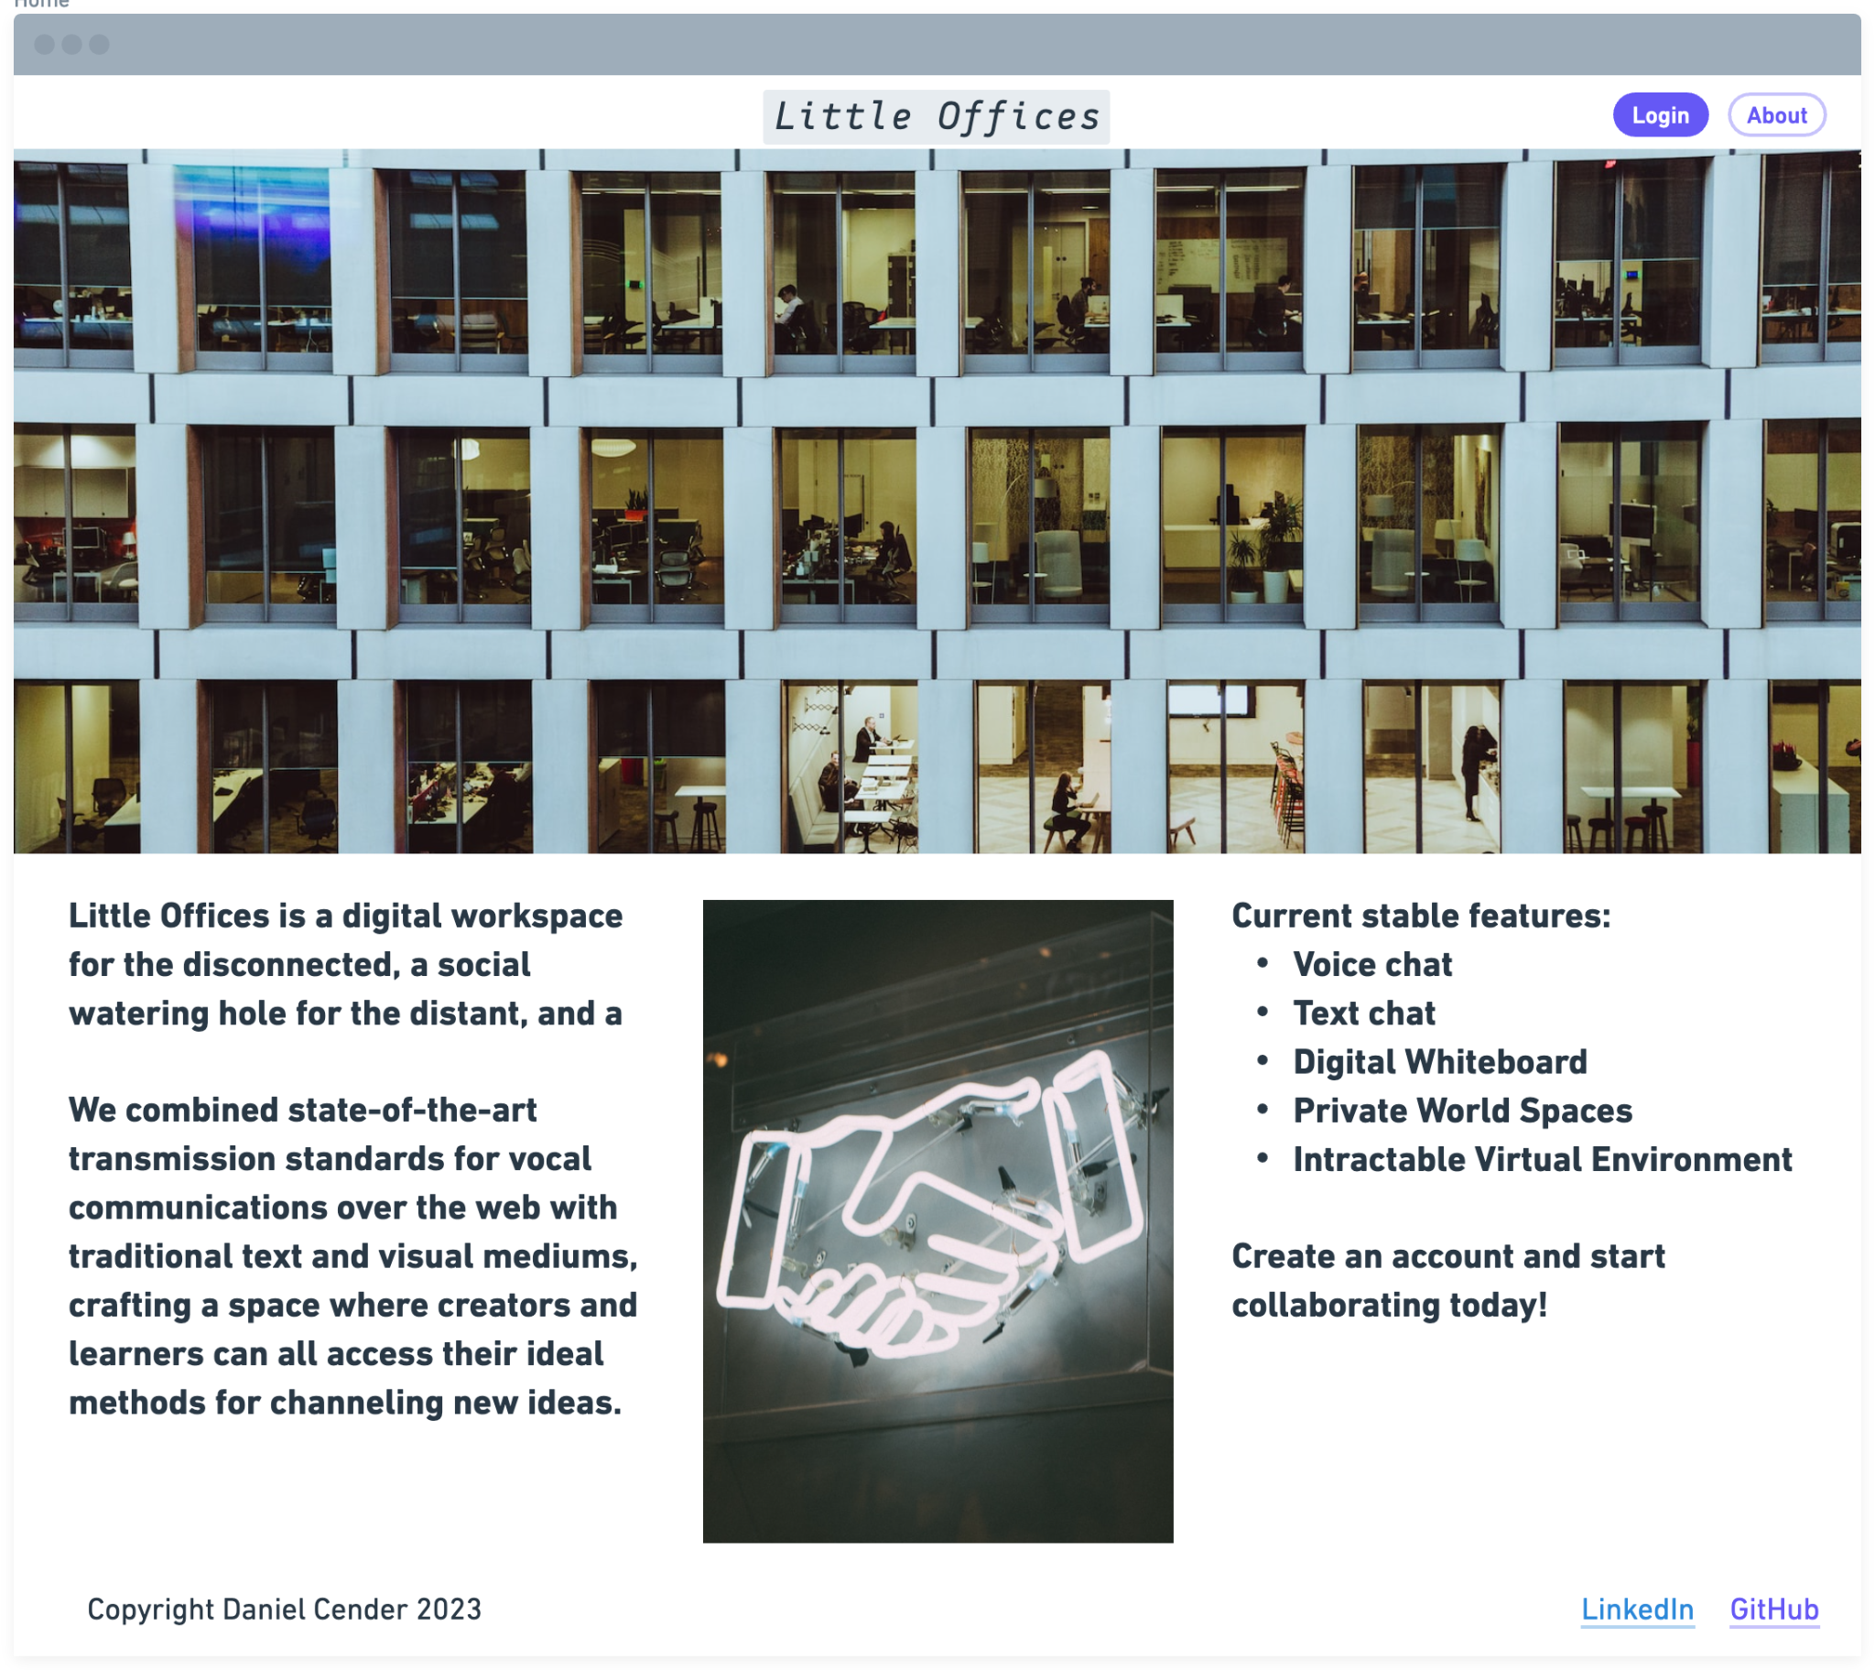

Sign in page:

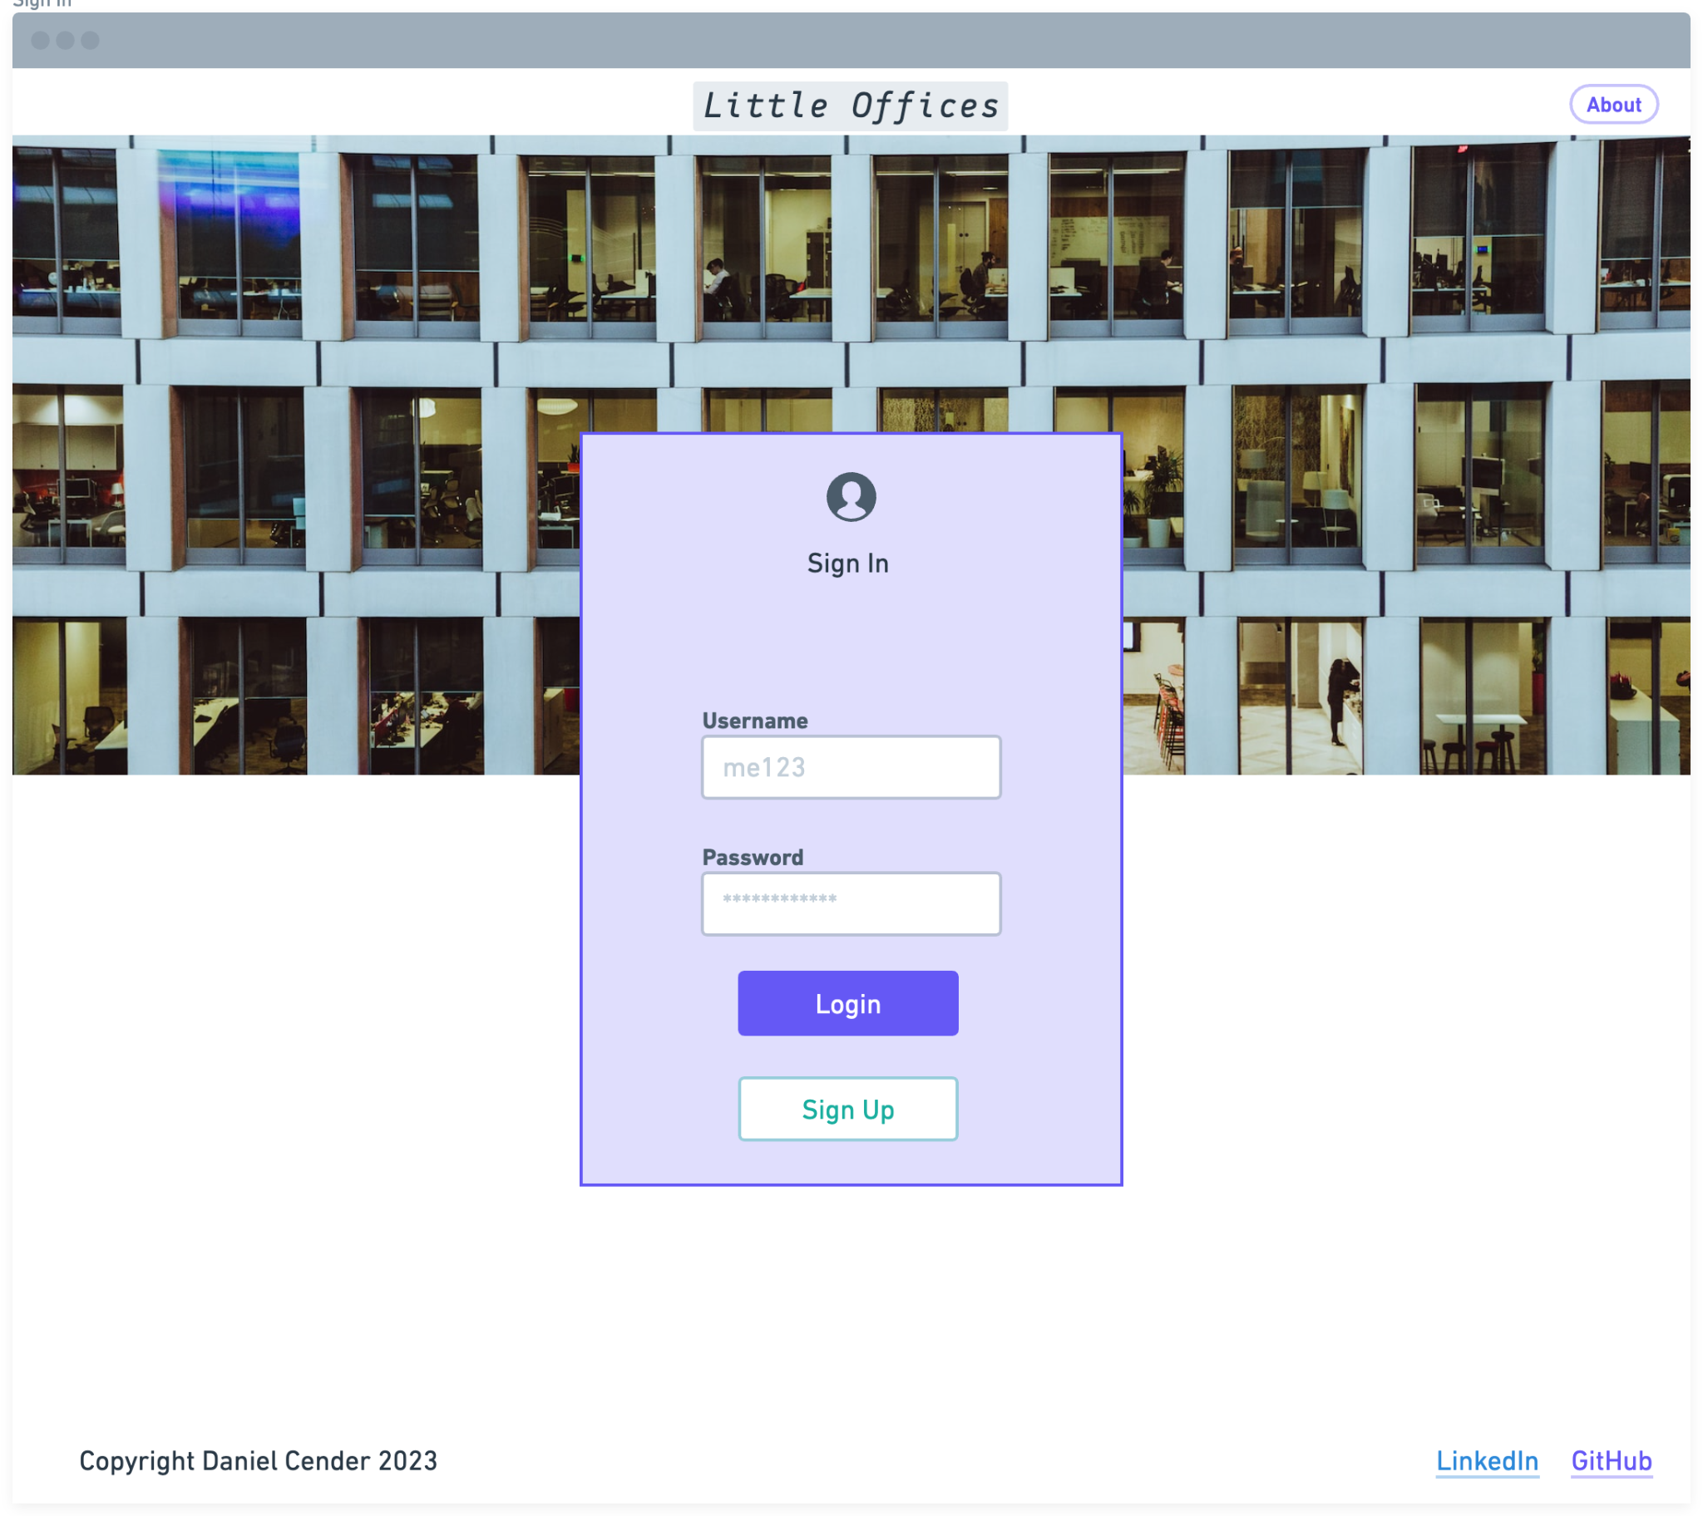

Sign up page:

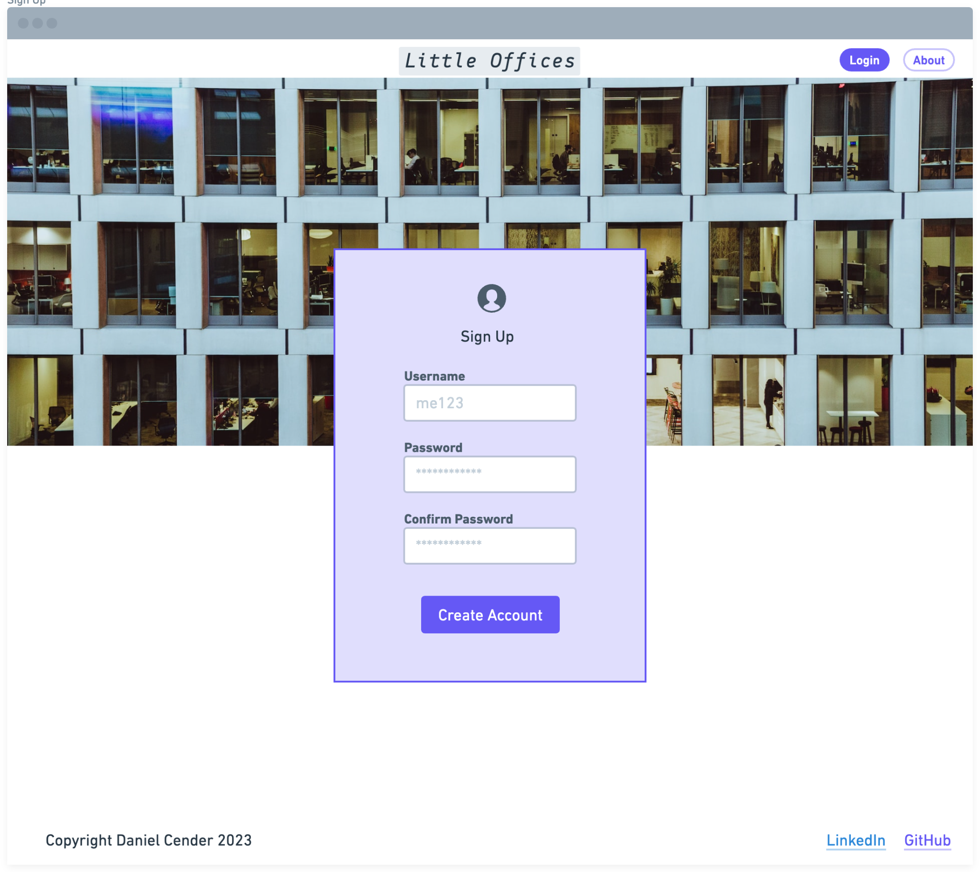

World Select Page:

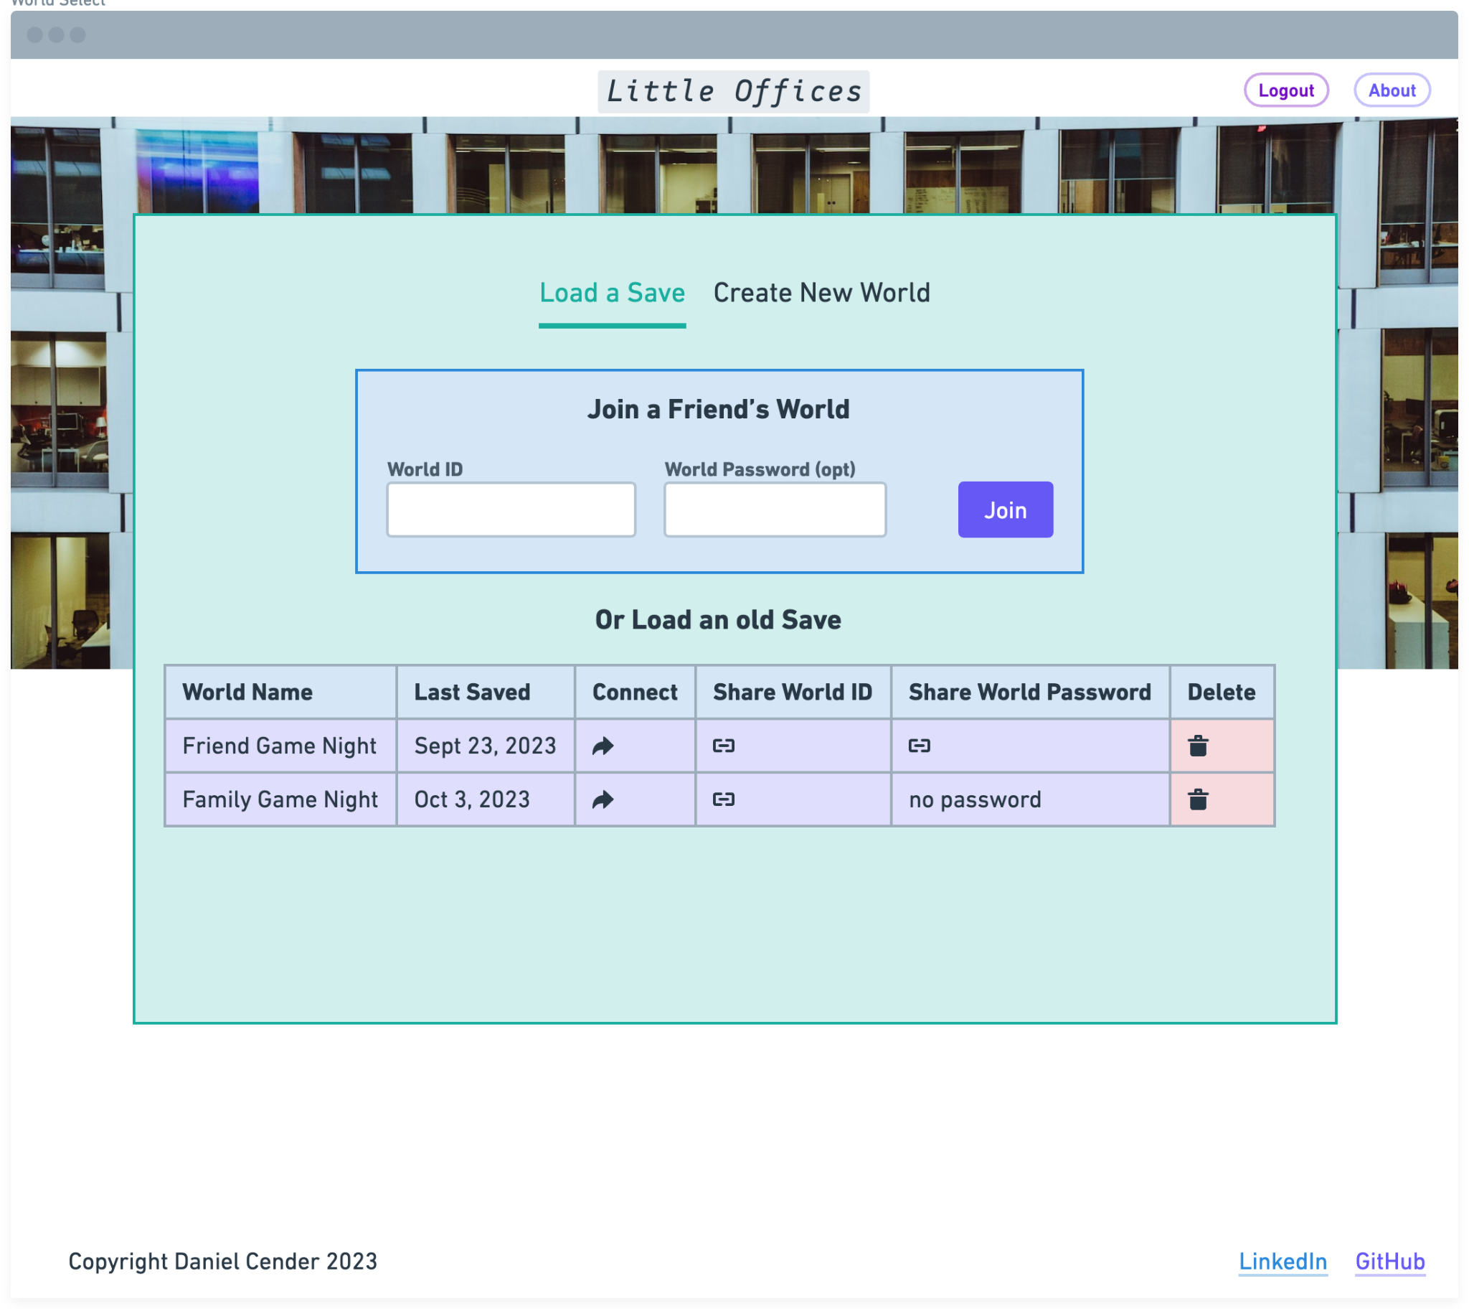

World Creation page:

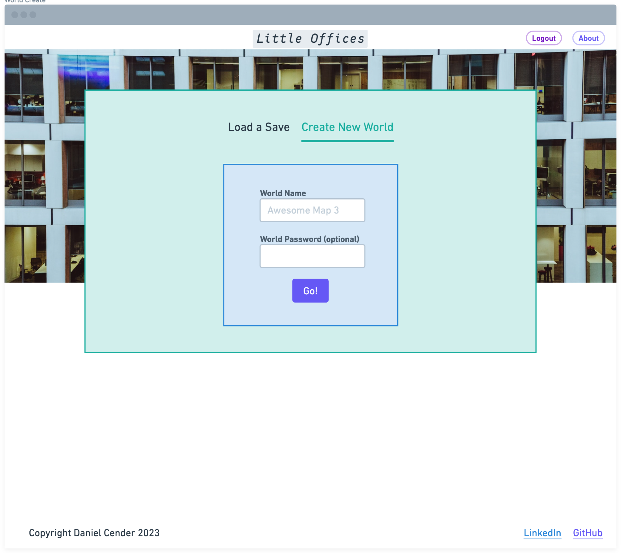

Avatar Select page (has since been cut from scope):

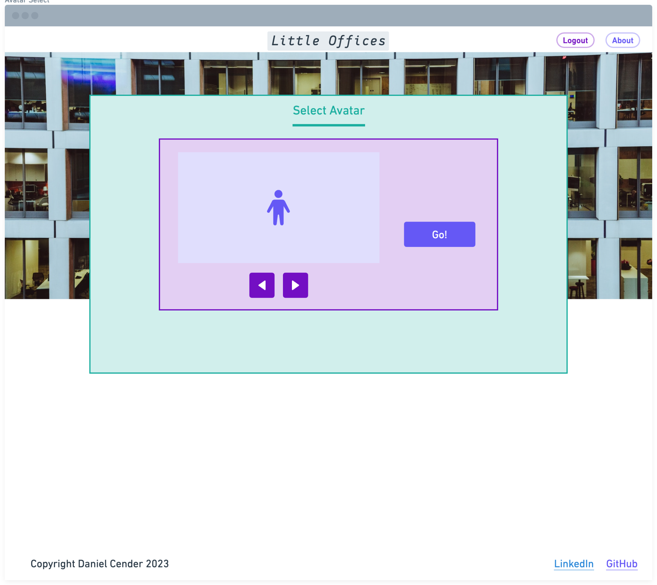

World Map Page:

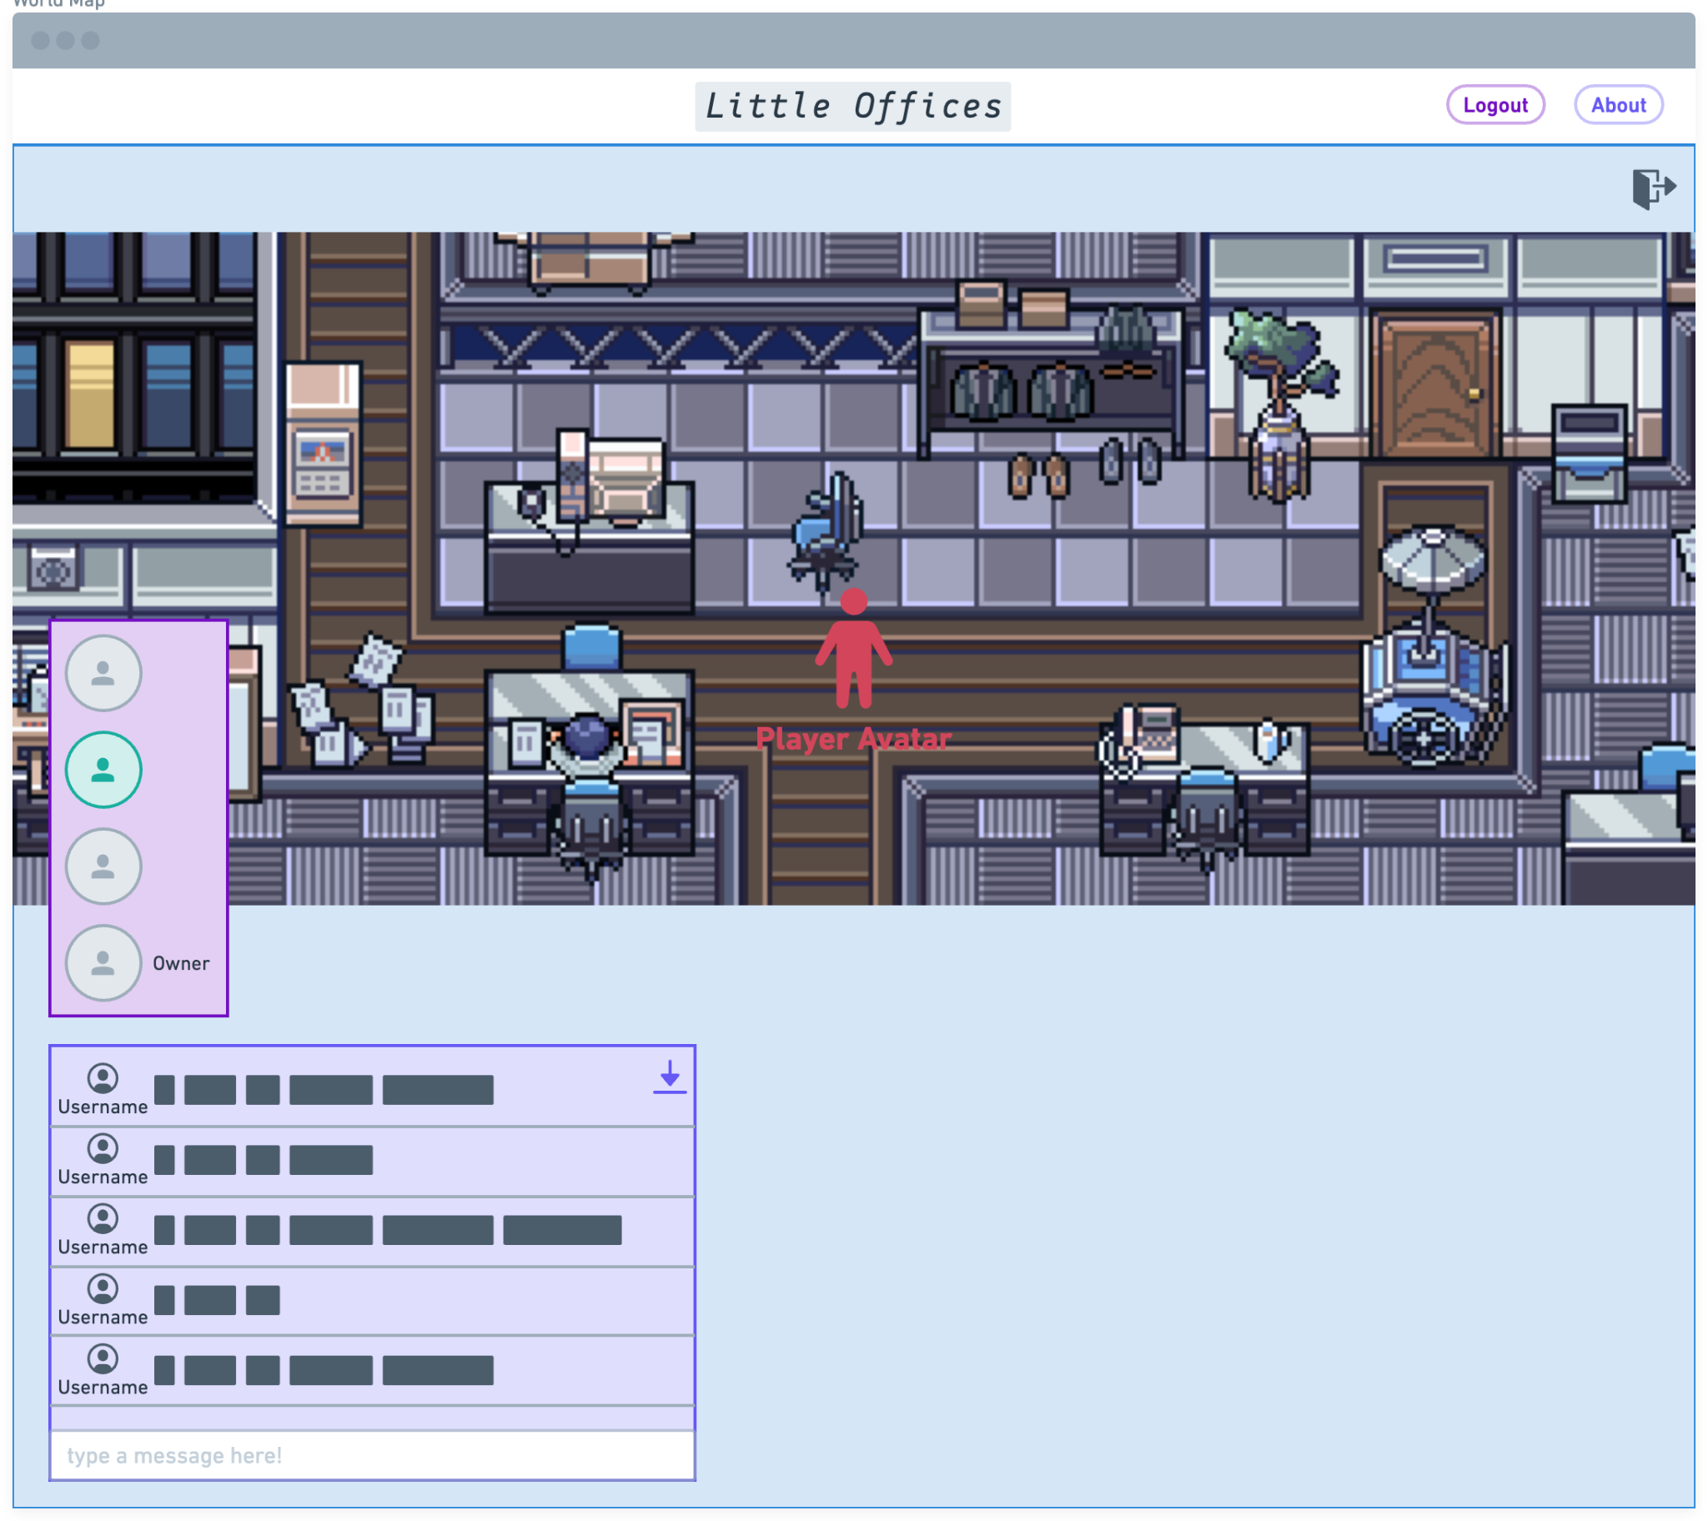

World Whiteboard Page (including the updated UI for the WBO Whiteboard):

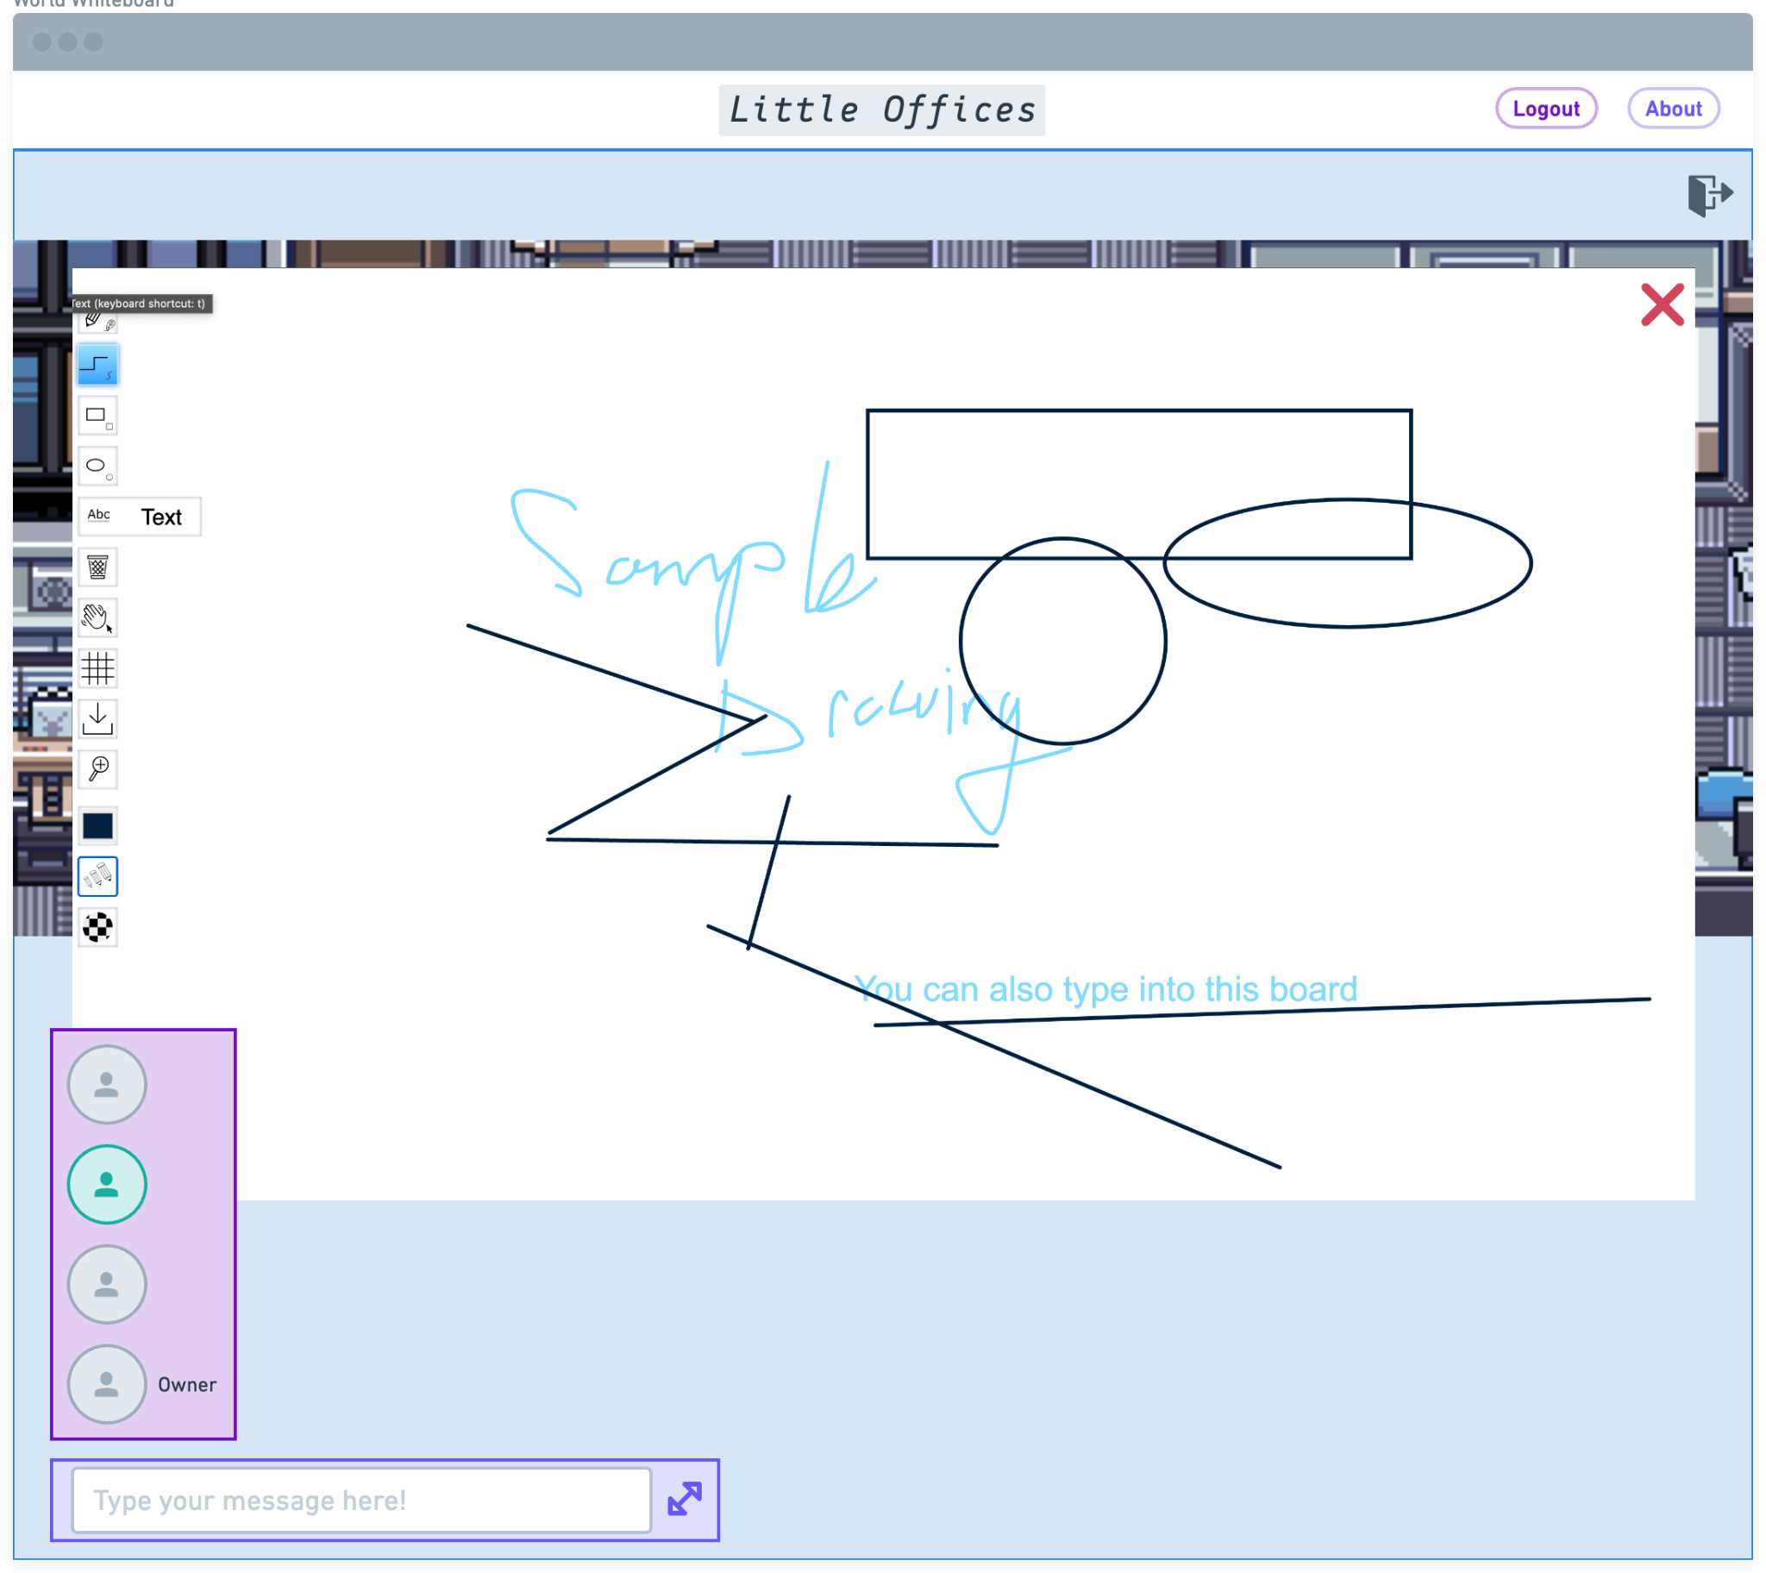

*Note: In development, the World Scene and Whiteboard pages were combined into the same WorldScene page. This now looks like the below example (with dummy data included):*

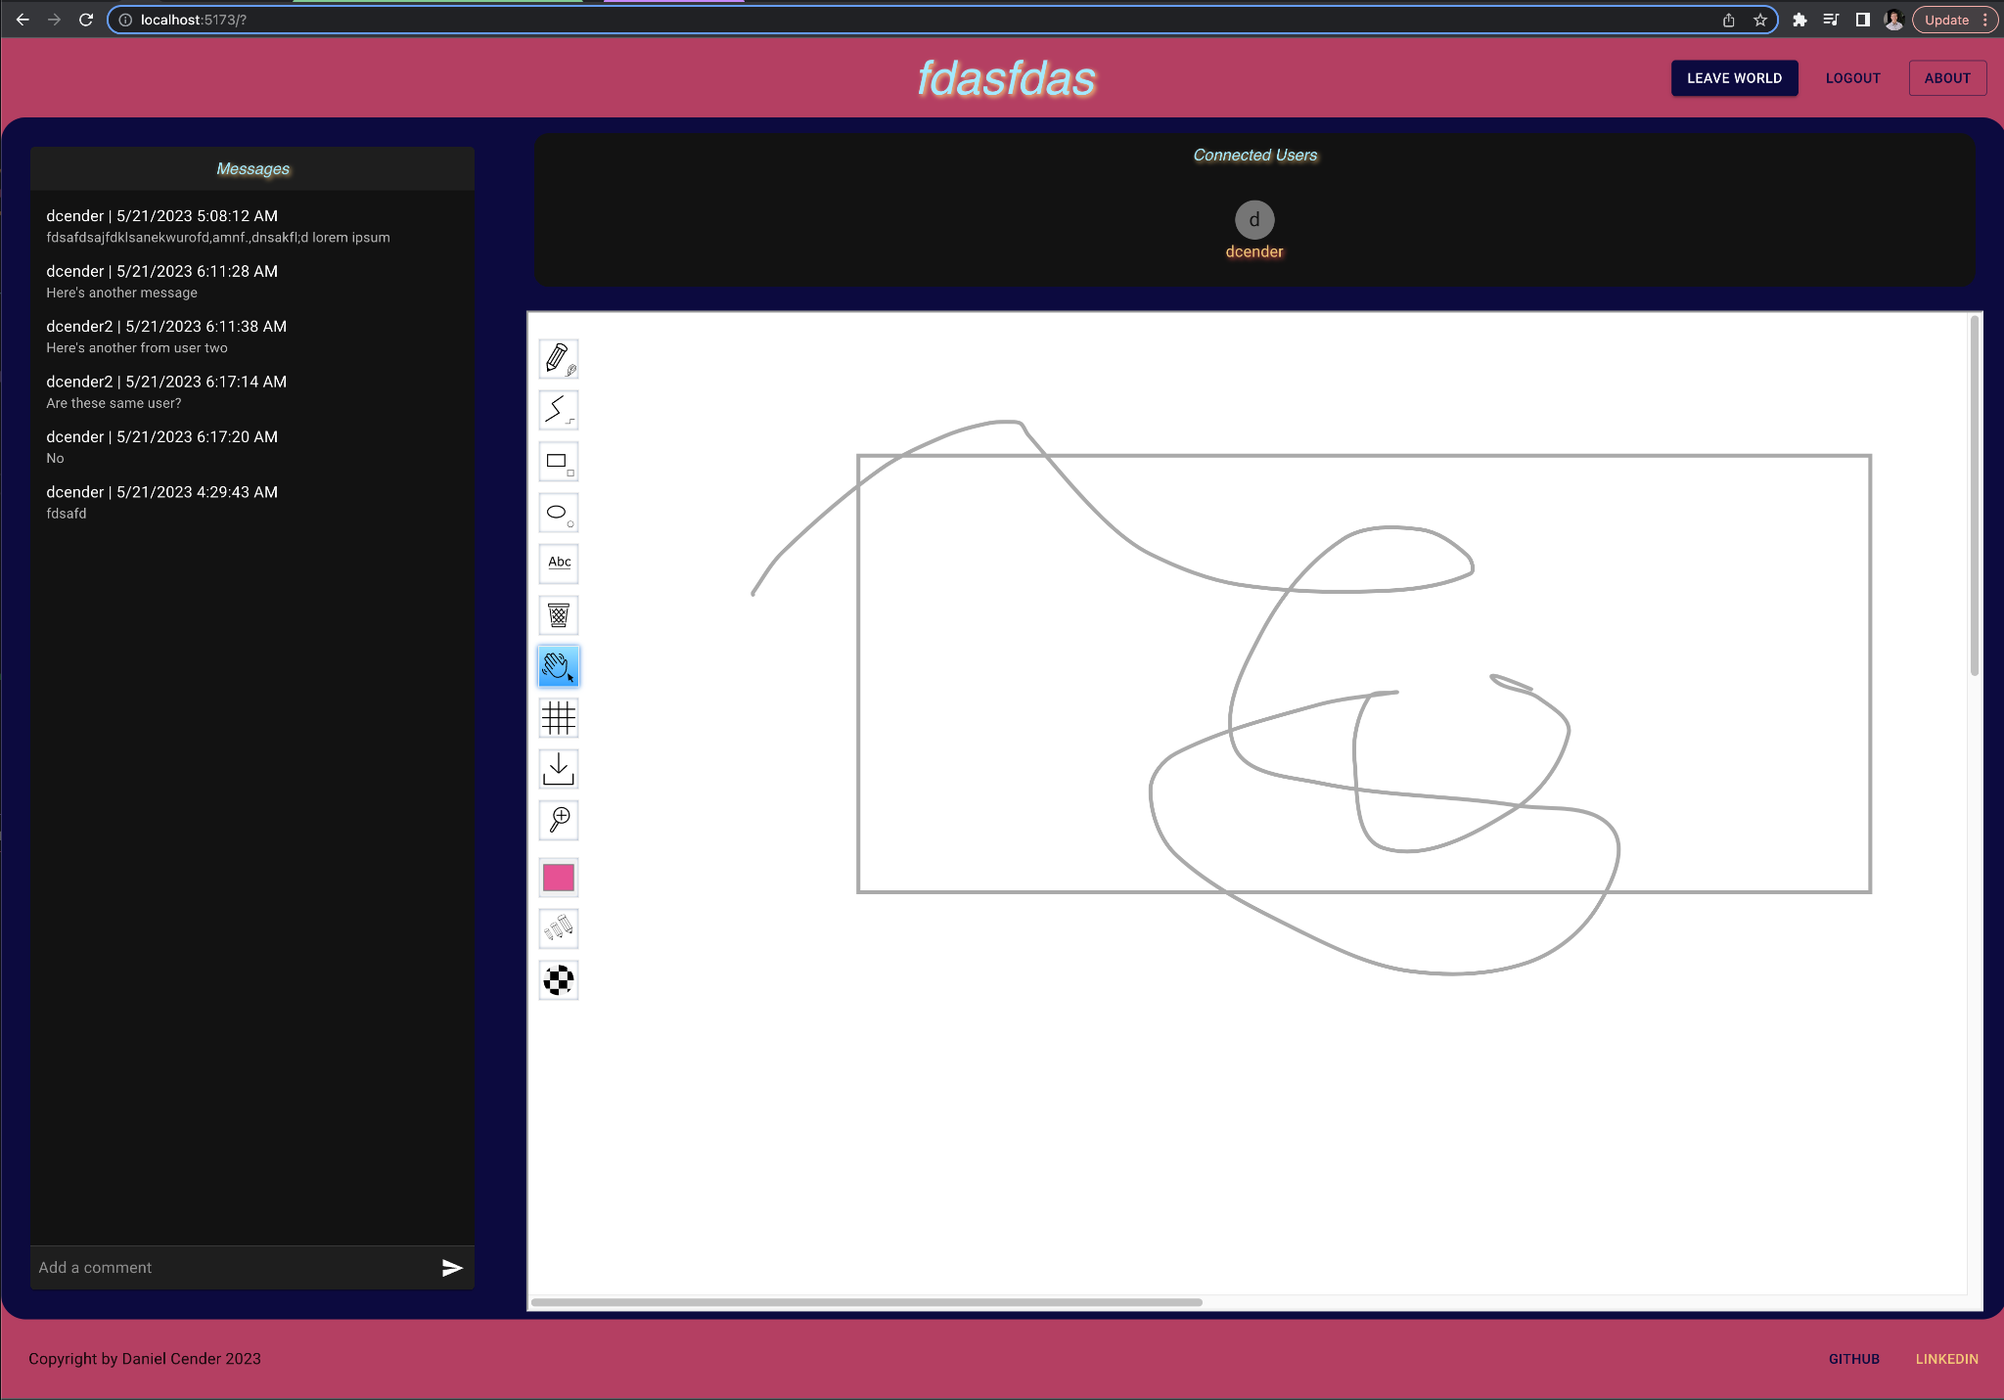

## UML Diagrams:

Below is a UML Sequence diagram for the flow of sending and saving a text chat message from the web app. The database will be used to pre-load any historical data associated with the world’s chat at startup, and so the server must save the message. But, the main function of the server is to pipe World state changes from one client to another, while validating the requested change for erroneous or unauthenticated requests.

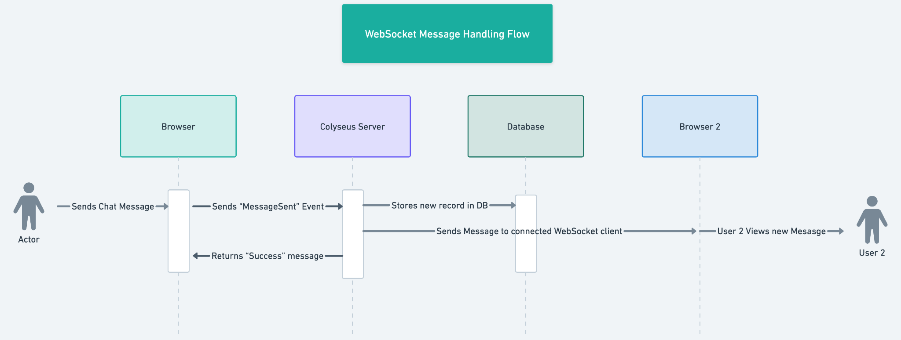

## Service API Design:

No external APIs are being deployed or accessed during the development of this project. The only service API deployed for this project will be the Colyseus server, and that will use its own framework code to transmit statically-typed data messages across WebSocket connections with clients. These message types will be specified in depth during implementation, but will include distinct messages and handling logic for at least: AddChatMessage, SendWorldData, ConnectToWhiteboard, and DisconnectFromWhiteboard.

## NFR’s (Security Design, etc.):

Security is a paramount NFR in this project, so proper password handling will be enforced over the full stack to ensure user integrity. While an initial thought was to use an external provider like Google Identity Service for providing user identification, it turned out faster to implement a custom username/password sign in flow myself. Passwords will be hashed before sending to the server, both for initial user creation and subsequent login attempts. Passwords will be constrained to be minimum 8 characters, with at least one uppercase and special character.

Using Netlify’s extensive content delivery system, users should have no issue with site availability in *Little Offices*. If the user base grew significantly, I could always expand the deployment to include multiple edge caches and premium deployment technical support.

Availability and dependability of the system will be supported by using a server framework built for multiplayer gaming systems. Colyseus provides strict typing and strong implementation patterns which will guide me to provide fault tolerances and error handling where possible instances might occur.

## Operational Support Design:

Because the application server is hosted in a heavily configurable environment (in Heroku), optional logging utilities are available (Logging | Heroku Dev Center, n.d.). I can access the runtime logs easily in my deployment console, which will be invaluable for debugging any issues which might occur in the deployed service. A sample add-on would be an integration with Sentry, a prominent logging service with great stack tracing support in many language runtimes.

## Other Documentation:

All estimated user stories, for both functional and nonfunctional requirements, are contained in a couple separate Excel documents: CST-451FunctionalRequirementStories.xlsx and CST-451NonfunctionalRequirementStories.xlsx.

# APPENDIX A – TECHNICAL ISSUE AND RISK LOG

1. Use the template to identify and monitor project issues and risks.

| Issues and Risk Log | | | | | | | | |
| --- | --- | --- | --- | --- | --- | --- | --- | --- |
| **Issue or Risk** | **Description** | **Project Impact** | **Action Plan/Resolution** | **Owner** | **Importance** | **Date Entered** | **Date to Review** | **Date Resolved** |
| I/R | What is the issue or risk? | How will this impact scope, schedule, and cost? | How do you intend to deal with this issue? | Who manages this issue? |  |  |  |  |
| Timeline slip |  | My progress will be set back by about a week as I enter into the second half of this capstone project. | Because research and planning took up most of my time during the first four weeks, I think just focusing on the implementation code at 10+ hours a week should get me to my desired goal. | Myself | Critical | Sun, April 23, 2023 | Sun, April 30, 2023 |  |
| Timeline Slip | Failed to achieve development goal for week | Need to minimize the complexity of the remaining workload | Cutting use of ThreeJS in favor of simpler HTML Canvas images and movements. | Myself | Crticial | Sun April 30, 2023 | May 7, 2023 | May 7, 2023 |
| Timeline Slip | Failed to deliver full testing and complete feature set by completion date | Required me to further chop features from the application. | Application will no longer have 2D visual simulation, instead just including the text and voice chat, as well as the shared whiteboard. | Myself | Critical | Sun May 14, 2023 | May 15, 2023 |  |
| Scope Slippage | Failed to finish building out the realtime audio transfer service | There are still solid modes of communication through the embedded whiteboard and the messaging box, but had to cut the PeerJS RTC implementation from project deliverable. | Will update final project documentation and future plans to include detailed notes on how I’d implement the PeerJS feature in a future project iteration. | Myself | Non-Critical | May 20, 2023 | - | May 21, 2023 |

# APPENDIX B – REFERENCES

*List all Project Documentation References*

*List all references using APA style*

*Building better teams, bit by bit*. Gather. (n.d.). Retrieved April 20, 2023, from <https://www.gather.town/>

*Logging: Heroku dev center*. Logging | Heroku Dev Center. (n.d.). Retrieved April 20, 2023, from https://devcenter.heroku.com/articles/logging#runtime-logs

*Virtual Office for teams*. Spot. (n.d.). Retrieved April 20, 2023, from https://www.spotvirtual.com/

WBO. (n.d.). Retrieved April 21, 2023, from https://wbo.ophir.dev/

# APPENDIX C – EXTERNAL RESOURCES

| **GIT URL:** | *https://github.com/DanielCender/GCUCapstoneProject* |
| --- | --- |
| **Hosting URL:** | *Web:* [*https://dcgcucapstone.netlify.app/*](https://dcgcucapstone.netlify.app/)  *Server:* [*https://little-offices.herokuapp.com/*](https://little-offices.herokuapp.com/colyseus/#/) |
| **Development Status Update Video** | *Sprint 1 (thru April 24):* [*https://www.loom.com/share/01c4945800134733aecd75e634ffe09a*](https://www.loom.com/share/01c4945800134733aecd75e634ffe09a)  *Sprint 2 (thru April 30):*  [*https://www.loom.com/share/7ca6e1b2bbae4277bfb2e26ddccbdbc7*](https://www.loom.com/share/7ca6e1b2bbae4277bfb2e26ddccbdbc7)  *Updated styling across all pages, added world selection page, wrote server route to handle world GET and DELETE HTTP requests.*  *Sprint 3 (thru May 7 - entered late on May 14):*  *Website reflects updates to route calls and displayed data.*  *Updated styling further, implemented better authentication patterns using JSON Web Tokens (JWTs), which will make further server route development easier and more secure. Officially removed Colyseus and replaced with custom WebSocket server setup using open-source “WS” Node.js package.*  *Sprint 4 (thru May 14 - going to be entered late, middle of Sprint 5):*  *Website now reflects further uplifted UI styling and fully-built messaging features, user status indicators, and whiteboard collaboration embedding.*  *Local Functionality Video walkthrough:* [*https://www.loom.com/share/73c2b67823a34e0389e024f65d8cbf3a*](https://www.loom.com/share/73c2b67823a34e0389e024f65d8cbf3a)  *Sprint 5 (thru May 21st):*  *// tbd* |